

Celebrating Our Partnership in Excellence!

Occupational Therapy Fieldwork 2025 Newsletter
Dear valued fieldwork partners, we're thrilled to have you collaborating with us on this rewarding professional journey! Your partnership is instrumental in shaping the next generation of occupational therapy practitioners.
Our Evidence-Based Approach
We've designed our Level I fieldwork curriculum around three powerful educational components:
- High-fidelity simulations - Creating realistic clinical scenarios.
- Service-learning outreach - Connecting students with community needs.
- Reflective video analysis - Enhancing clinical reasoning through self-assessment.
Student Progress
- Class of 2026: Currently completing their final Level II fieldwork and are preparing for their Capstones for spring 2026.
- Class of 2027: Concluding their didactic coursework and preparing for their first Level II placements for 2026.
- Class of 2028: Finishing their third semester and currently completing their first level I fieldwork
Take a look inside our Sim Center: Picture below: Outpatient Offices, where our students meet standardized patients from the community trained in the OT process.
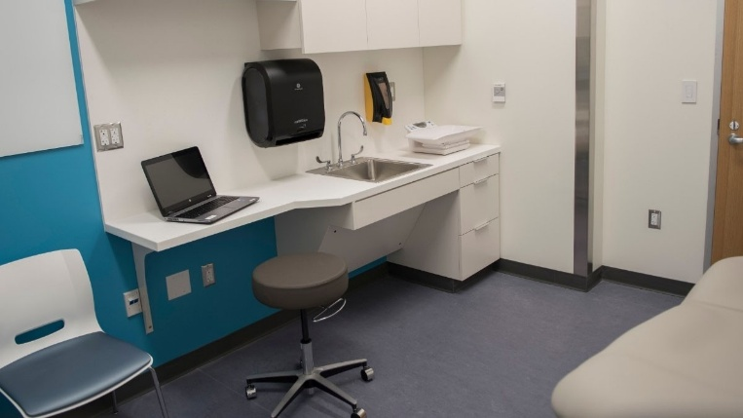
Functional Living Lab: Where Home Modifications and Fall Prevention Occur!
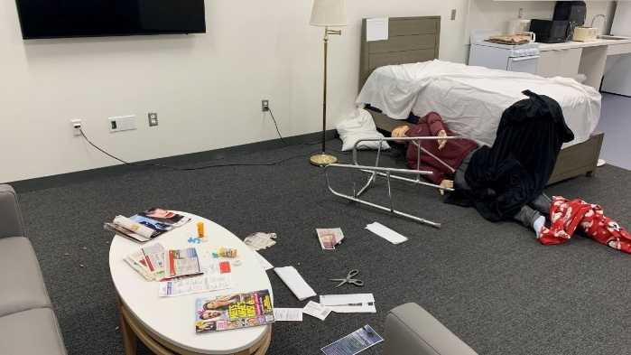
Body Swaps Virtual Reality is Being Utilized in our OT fieldwork education to help students develop soft skills for professional engagement and Client-Centered Care.
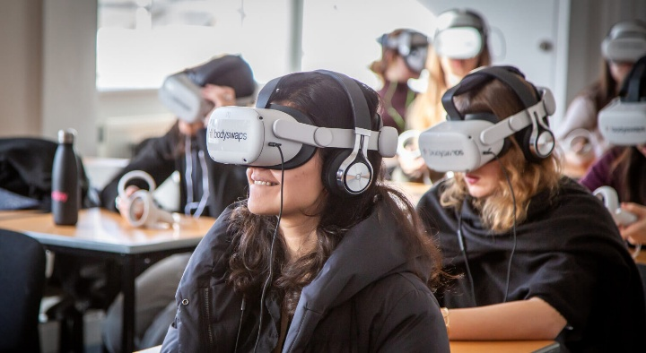
Connect With Us!
Boyda9@nku.edu

Read More about NKU OTD (click here)!
Thank you for partnering with us on the journey!

Simulation Center: Northern Kentucky University, Greater Cincinnati Region
Bodyswaps | VR soft skills training | AI-powered soft skills training

